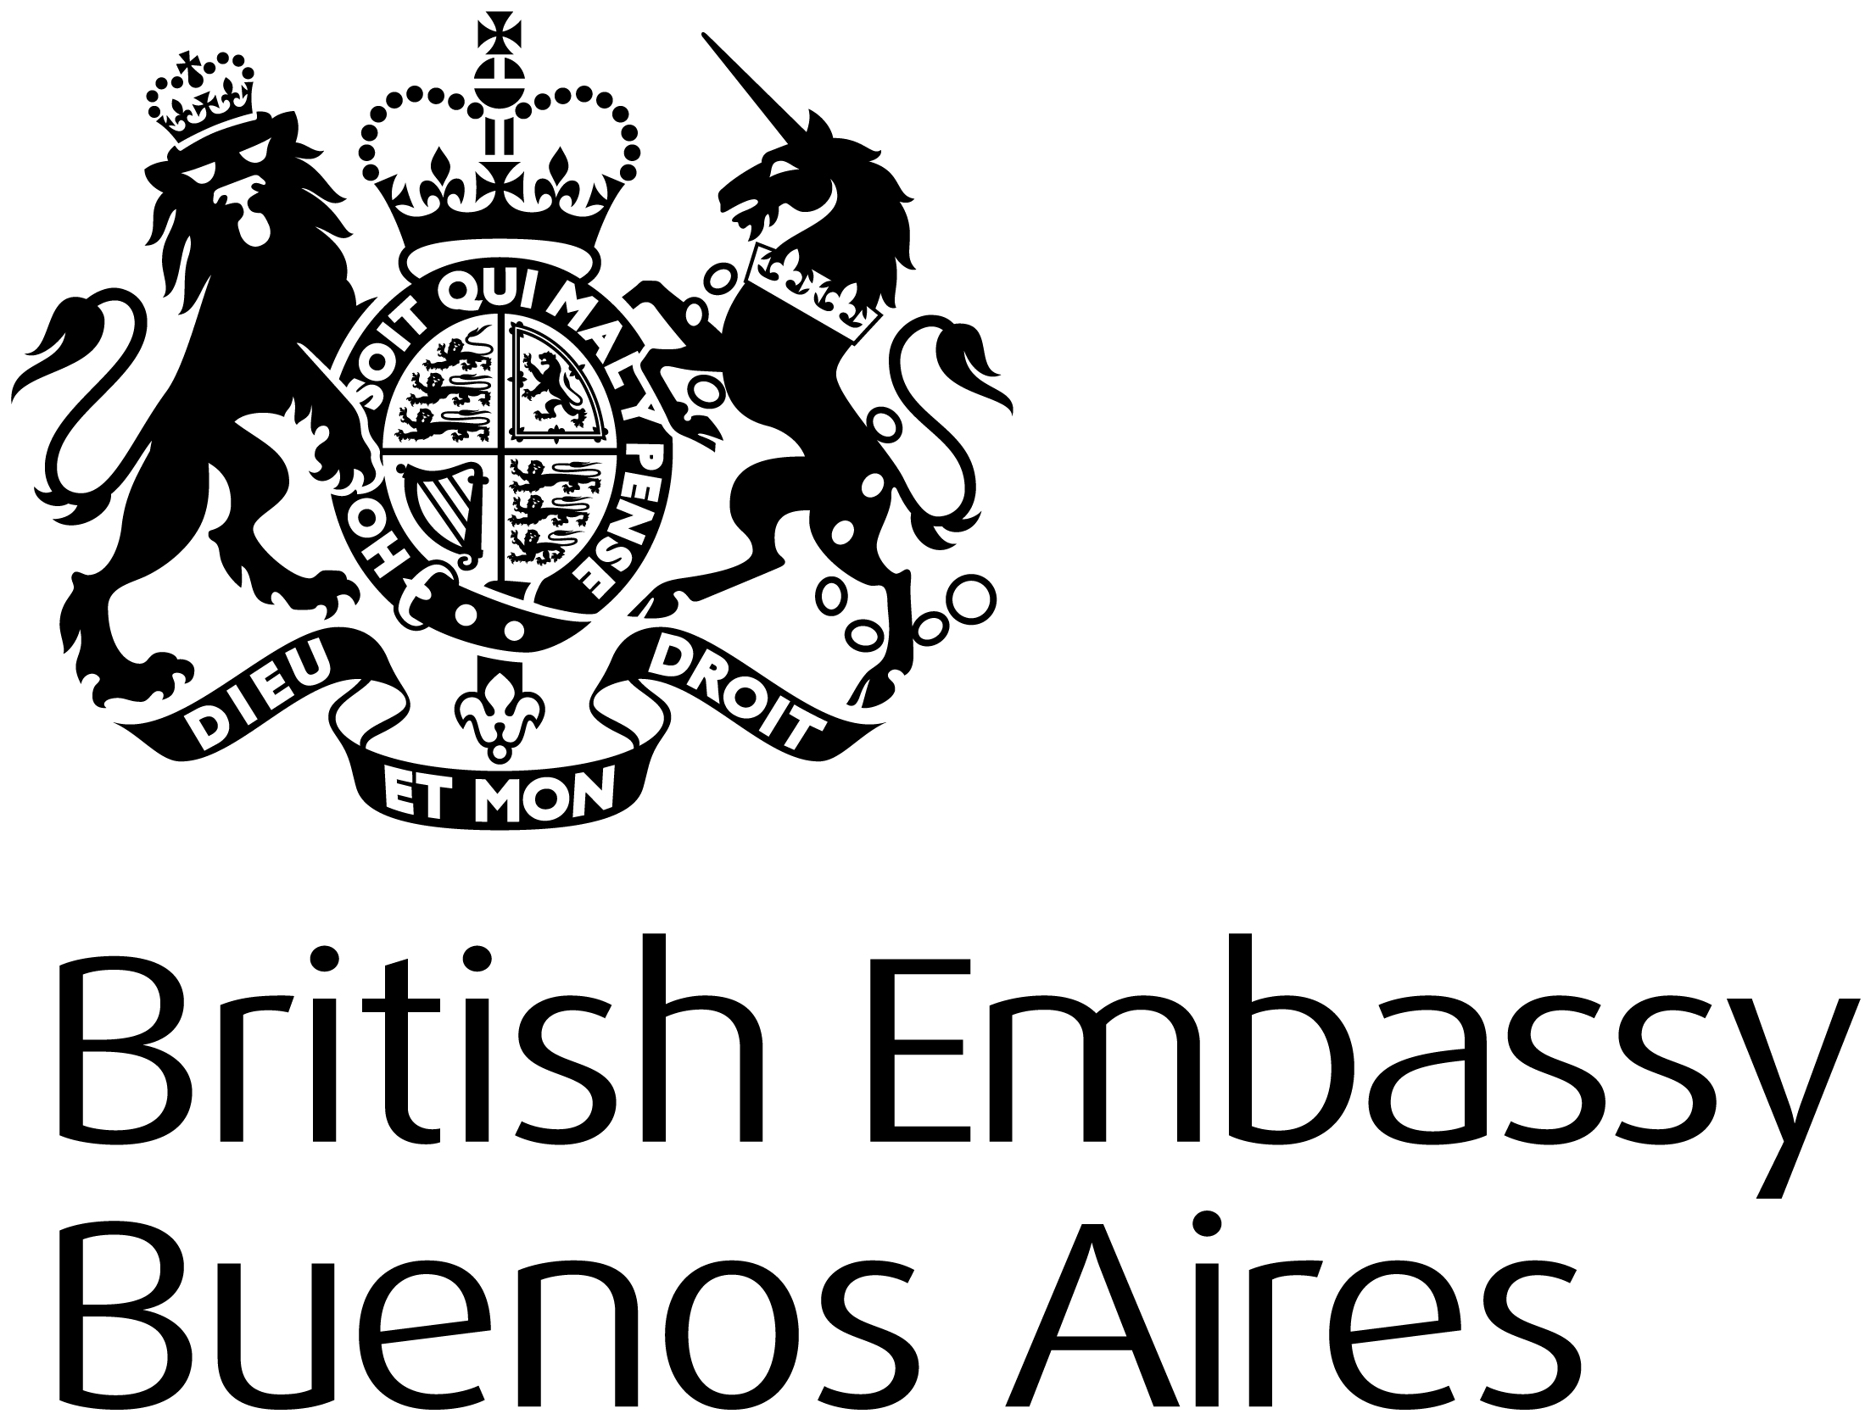
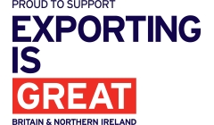
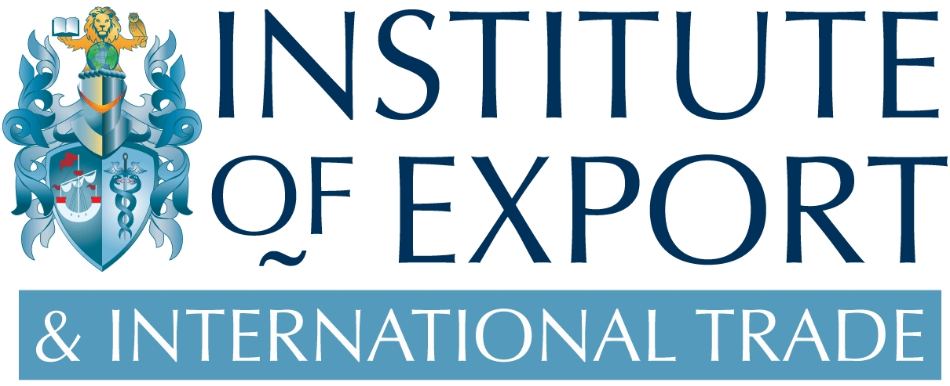

PRESS RELEASE

Date: 16th October 2018
For immediate release

Contact: Craig Smith – Project Director
Email: craig.smith@export.org.uk / Tel: +44 (0)1298 79562

‘Doing Business in Argentina Guide’ launch

The ‘Doing Business in Argentina Guide’ website is now live and the hard-copy brochures are currently being printed and distributed.

16th October 2018 – The ‘Doing Business in Argentina Guide’ is now officially live and can be accessed via: www.Argentina.DoingBusinessGuide.co.uk.

The main objective of this Doing Business in Argentina Guide is to provide you with basic knowledge about Argentina; an overview of its economy, business culture, potential opportunities and to identify the main issues associated with initial research, market entry, risk management and cultural and language issues. We do not pretend to provide all the answers in the guide, but novice exporters in particular will find it a useful starting point. Further assistance is available from the Department for International Trade (DIT) team in Argentina. Full contact details are available in the guide.

To help your business succeed in Argentina we have carefully selected a variety of essential service providers as ‘Market Experts’; Andina PLC, Cincotta International Advisory, Coldwell Banker Argentina/Coldwell Banker Commercial Argentina, HSBC Bank ARGENTINA, IRSA Inversiones y Representaciones SA, Pistrelli Henry Martin y Asociados SRL and St George’s College.

The guide has been produced by International Market Advisor, in partnership with the Institute of Export & International Trade, and with support from the British Embassy Buenos Aires, the British Chamber of Commerce in Argentina (CCAB), and the British Argentine Chamber of Commerce (BACC).

Five things to know about exporting to Argentina:

- Argentina has a highly diversified economy. The primary sector is internationally renowned for its high productivity levels and use of advanced technologies.

- Argentina has signed almost sixty bilateral investment treaties and created an entire law (Foreign Investment Law No. 21,382) to regulate and protect foreign investment.

- Argentina is the UK’s third largest export market in South America, with exports of goods and services worth £615 million in 2016 (goods £321 million; services £294 million), and goods exports increasing by 44% year-on-year over the 12 month period to April 2018.

- Now over 100 UK companies operate in Argentina. This includes over 20 FTSE 100 companies such as BT, GSK, HSBC and Unilever, as well as a range of small and medium-sized UK companies.

- The leading industrial sectors by gross value of production are food processing, beverages, chemicals and pharmaceuticals; motor vehicles and auto parts and coke fuel, oil refining and nuclear fuel production. With respect to services, sectors with the largest share in gross value added include wholesale, retail, and repairs; followed by transport and communications. The service sector leads the labour market as the biggest job creator.

